# Overview

The output from a schedule is important as a communication tool; therefore tailoring the view can be helpful to address the information needs of the audience. Views can be customized by formatting text, formatting bars, applying quick styles, and altering the general layout of the page. Printouts can be in Project file format, in PDF format, or image format. These options help you communicate with Project and non-Project users.

Besides a traditional view, reports can be created to communicate with others. Three popular report categories include Visual reports, Dashboard reports, and Timeline view reports. A Visual report exports information into Visio or Excel for further manipulation. A Dashboard report creates a visual output with blocks or sections of information such as graphs or tables. Dashboards may continue through multiple pages. A Timeline view report is designed for communication information at a high-level and it is easily transferred to other programs such as Word or Outlook. As you work with the individuals involved in your schedule, you will be able to determine the best output based on their needs.

# Printing

Most of the print settings in Project 2013 are similar to other Microsoft Office products. Unique to Project 2013 is the ability to include project and task data in report titles using the header and footer options. We will also discuss printing Gantt charts on paper or using Gantt charts in presentations.

In this lesson, we will discuss:

* Print Settings
* Page Setup Options
* Copy Picture

## Print Settings

Project 2013 gives you the ability to customize how a report will be printed. Seeing the final report before it is printed assures the user that they are printing the correct report in the format needed. Print options allow the user to select a printer and fine-tune which data will be printed. When the print options are selected, the current active project view will be printed.

To display print options :

* File → Print

To close print options:

* Click any tab above the ribbon bar

In table #.1, Gantt Chart is the active view. On the left side of the screen, several options are available:

1. Print screen options

|  |  |
| --- | --- |
| Option | Action and result |
| Print | Sends the report to the selected printer. |
| Copies | Determines the number of copies that will be printed. |
| Printer | Clicking the arrow on the right side of the box will open a drop-down menu and display all available printers. |
| Printer Properties | Clicking on the link will display additional printing properties. |
| Settings | Allows you to select which printer the image will be printed on |
| Dates | Allows for selection of a date range for the printed report |
| Pages | Allows for selection of specific page range |
| Orientation | Landscape or Portrait |
| Paper size choice | Select from a variety of paper sizes |
| Page Setup | Dialog box that will allow for more customization choices |

Notice how the print screen maintains your options on the left and provides a preview of what the result will look like on the right. This gives you the flexibility to make changes before sending the schedule to the printer.

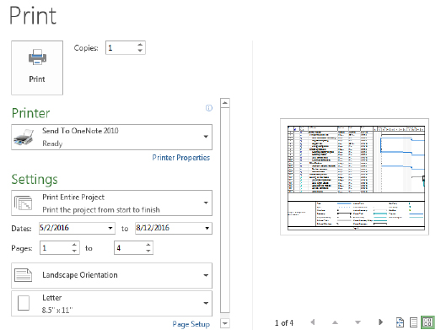

1. View of Printing options. [12-1 Print screen view.tif]

Click the down arrow on Settings to display more options to further refine the final printed report. These options are:

1. Print Options from the File Tab

|  |  |
| --- | --- |
| Option | Action and result |
| Print Entire Project | Default value. The entire project schedule will be printed using the current view. |
| Print Specific Dates | Only the data between the date range will be printed. This option is not available for all reports. |
| Print Specific Pages | Select specific page numbers to print. |
| Print Custom Dates and Pages | Date range and page number range will be printed. |
| Notes | Add the project notes to the printed report. Notes will be printed on a separate notes page. |
| All Sheet Columns | When selected, all columns within the current view will print. |

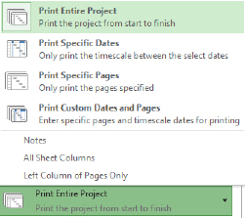

1. Print choices available when the Settings option is selected on the Print option screen. [12-2 Setting options view.tif]

Page orientation and paper size options are also available.

Viewing options to preview the final report are available by clicking on the buttons below the active project view in the lower right corner of the screen.

1. Adjustment options available in the lower right corner of the Print options screen

|  |  |  |
| --- | --- | --- |
| Button | Represented by | Result |
| Left arrow |  | Move one page to the left. |
| Up arrow |  | Move one page up. |
| Down arrow |  | Move one page down. |
| Right arrow |  | Move one page to the right. |
| Actual size view |  | Actual size of printed report. Use sliders to see the entire page. |
| One page |  | Report will show one page at a time. |
| Multiple pages |  | Report will show in multiple page format. |

Notice in this screen shot the preview options at the bottom. These are often overlooked and will let you quickly preview another page or show either a single page or all pages at once. 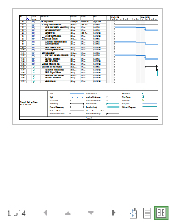

1. Print preview side of the Print options view. [12-3 Right side of print option view.tif]

Add the Print Preview button to the Quick Access Toolbar:

Click on the down arrow on the right side of the Quick Access toolbar

Select Print Preview

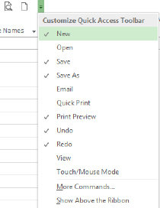

1. Add Print Preview to the Quick Launch Bar. [12-4 Quick Access toolbar.tif]

# Page Setup Options

Page setup options are similar to options available in other Microsoft Office products. Project 2013 has some unique options specifically for the types of views available in the application. These unique options will be discussed in this lesson.

Project level data may be entered for project name, author, company, etc. and applied to the project header and footer information. This information is entered using the Advanced Properties dialog box. Once the data has been entered, the header and footer information is configured per report using the Page Setup options.

To add information in the Advanced Properties dialog box:

* File → Info → Project Information → Advanced Properties

The dialog box is shown below:

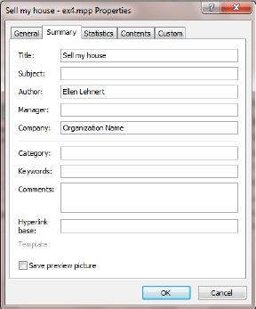

1. Advanced Properties box. [12-5 Advanced Properties box.tif]

To display the Page Setup dialog box:

* File → Print → Page Setup

A dialog box will appear with the Page tab displayed. The options on this tab are similar to other Microsoft Office applications. The Margin tab contains the margin settings for the current report and an option to print borders around the data. Adjust these values as needed. The Header and Footer tabs allow for configuration of titles and footer information for reports. The view below shows the Header tab used for adding the project title values.

To add Header or Footer information to the title of a project:

* Click the Header or Footer tab.
* Click on the Left, Center, or Right tab in the lower section of the box.
* Click the down arrow to view the General drop-down menu.
* Select field value.
* Click Add.
* Repeat for additional data.

The Header and Footer settings are unique per report and should be checked using Print Preview before each reported is printed.

A current date is not preset to show in either the header or the footer title lines. Add the system’s date using the center button above the General drop-down menu.

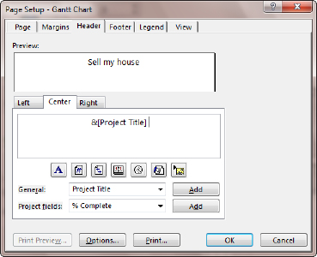

1. View of the Header tab in the Page Setup box. [12-6 Header view.tif]

The Legend tab is used to customize or turn off the legend printed on Gantt charts. If unique Gantt chart formatting has been created, the alternate color coding will automatically appear in the legend when the Gantt chart is printed. The Legend Labels button allows for font color and font selection changes. To disable the legend printed on Gantt charts, select None on the right side of the dialog box .

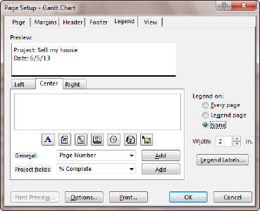

1. Page Setup box viewing the Legend tab. [12-7 Legend option.tif]

The View tab contains options for specific views, but not all options will be available for each report. The options on the View tab are:

1. Options available for Printing reports on the View tab of the Print Preview box

|  |  |
| --- | --- |
| Option | Result of selecting option |
| Print all sheet columns | All columns in the table of the active view will be printed. |
| Print first (enter number) columns on all pages | Specify the number of columns to be printed on all pages of the report. When printing a Gantt chart, it is advantageous to add the task name to all pages.  In Gantt Chart view, the first column of pages in your printout can be further refined by dragging the dividing bar which separates the entry table (left) and timescale (right) side. |
| Print notes | A separate notes page will be added to the report. Task ID numbers will be used to tie the note to the task. |
| Print blank pages | When printing Gantt charts, blank pages might result. Should these pages be printed? |
| Fit timescale to end of page | Adjusts the timescale for the report. |
| Print column totals | Adds totals to Resource Usage and Task Usage reports. |
| Print row totals for values within print date range | Adds totals to Resource Usage and Task Usage reports. |

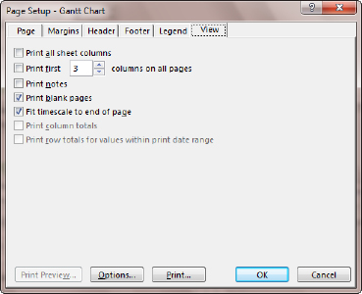

1. Page Setup box with View tab displayed. [12-8 View tab.tif]

## Copy Picture

Use the Copy Picture tool to take a picture of your active view and store it on the clipboard. After it is stored, it can be pasted into PowerPoint, Word, Excel or any other application.

To use the Copy Picture tool, the view must be displayed and refined for the picture. Navigate to the view to be copied. Some adjustments to a view might include:

* Expand or collapse the work breakdown structure.
* Adjust timescale.
* Adjust titles in the timescale.
* Change formatting.
* Highlight tasks.
* Add drawing elements.

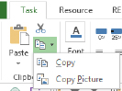

1. Copy Picture. [Copy Picture.tif]

To use the Copy Picture tool:

* Click Task → down arrow to the right of the Copy Button → Copy Picture.

If printing a Gantt chart, adjust the vertical bar in the middle to show the columns to be included and click Copy Picture to open the Copy Picture dialog box shown below.

* Render image - select image to render For Screen, For Printer or To GIF image file.
* Copy - rows on screen or Selected rows.
* Timescale - as shown on the screen or date range.
* Click OK to copy to the clipboard.

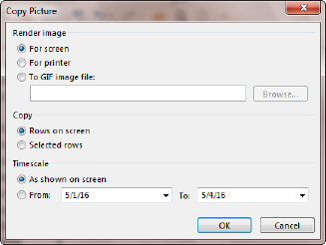

1. Copy Picture options box. [12-11 Copy Picture.tif]

Use the image to paste into a Powerpoint presentation, a Word document, an email or other application. After pasting, resize the image as necessary.

# Save as Project file in .PDF format

In Project 2013, we have the option to save project files as PDFs. Access to the option is located in the backstage view:

To create a .PDF file from the current view:

* File → Export → Create PDF/XPS Document → Create PDF/XPS

You will then be asked to select a location for the completed file. .PDF will be the default file type. Click on this value to change to .XPS files if necessary.

Click OK

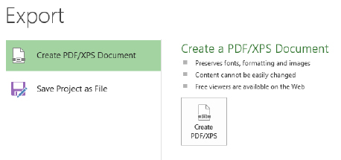

1. Export file image as .PDF options. [Save as .PDF.tif]

You will then be given Document Export options to make some adjustments to the image:

* Publish Range: All or date range
* Include Non-Printing Information: Document Properties and Document Showing Markup
* PDF Options: ISO 19005-1 compliant (PDF/A)

Click OK to complete creating the .PDF image.

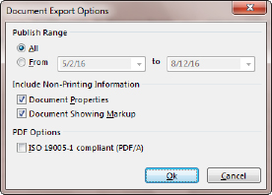

1. Create .PDF, Document export options. [Save as PDF Document Export Options.tif]

The Save As PDF function is limited to a single-pane view (i.e. without a split). If you have Gantt Chart with Timeline view dis-played, the PDF will generate based on the currently selected (active) pane. This will be either Gantt Chart or Timeline, not both.

# Email a Project file as an Attachment

Another way to communicate project information is to email a copy of a project file to someone. The person who receives the file must have MS Project 2010 or MS Project 2013 to open the file.

To attach the open project file to an email:

File → Share → Email → Send as Attachment

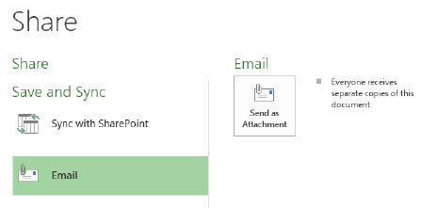

1. Share options in the backstage [Email as attachment.tif]

After clicking “Send as Attachment” Outlook will start, an email will be opened, the subject line will contain the name of the project and the file will be an attachment. Simply enter who the email should be sent to and add your comments. Click Send when you are ready to send the message.

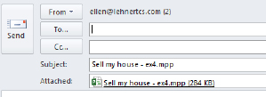

1. Project file as an attachment in an email. [Email in Outlook.tif]

# Refining Gantt Chart Formatting

The Gantt chart view may be altered as necessary to show the Gantt chart as needed for reports. Changes may be made to formatting, the time scale and data which is shown on the chart. In this section we will discuss these functions.

## Using the Format Tab

The Format tab buttons help you customize the text, columns, colors, and other elements of each type of view. The groups and buttons in the Format tab are different for each type of view. If you are viewing a Gantt chart view you will receive a different set of options than you would if you were viewing the Resource Usage view. Below is a view of the Format ribbon when the Gantt chart view is displayed. The next two ribbon examples are the Format ribbon when viewing the Resource Usage view and the Team Planner view.

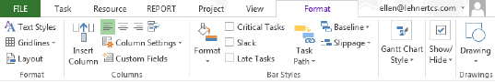

1. Project Ribbon – Gantt Chart Format Tab. [12-12 Format ribbon.tif]

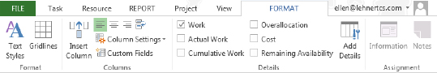

1. Project Ribbon – Resource Usage Format ribbon. [12-13 Project Ribbon - Resource Usage Format Tab.tif]

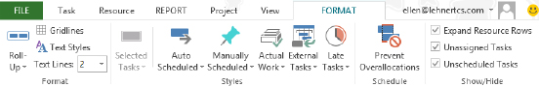

1. Project Ribbon – Team Planner Format tab. [12-14 Team Planner format tab.tif]

Any Gantt chart may have changes made which will enhance the message you are trying to convey. For example, you can add the baseline or slack to the Gantt view. Right clicking on a Gantt bar and selecting Format Bar will allow you to change the color of a specific bar to quickly highlight specific tasks, or perhaps you want to add text to specific bars to help you identify them. Any changes that are made to a view will be held in the view and will be remembered the next time the view is displayed in the file.

Any changes you make to one Gantt Chart view do not change the look of other Gantt Chart views. For example, if you apply formatting to the Gantt Chart view, this will not carry over to the Detail Gantt view.

## Formatting Text Styles

You can use text styles to change the format of text for one cell in a table or apply a unique format to an entire category of information, such as all critical tasks or all Milestone tasks. You may also want to change text to be more readable or to look distinct to garner attention for certain tasks.

You can format the text the same way for any view.

You can’t format fonts in the Calendar view, but you can format categories of text, so text will have distinct formatting for items such as all critical tasks or all summary tasks.

### Formatting Selected Text

To format selected text:

1. Select the cell(s) containing text that you want to format.
2. In the Ribbon, Task tab, Font group, click on the desired options or click on the dialog box launcher to display the Font dialog box.
3. Font Dialog Box. [Font dialog box.tif]
4. From the three lists across the top of the dialog box you can select Font type, Font style and/or the Font Size. You can also select an Underline or Strikethrough check box and set the Font color, Background color and/or choose a Background pattern. A preview of your selection will appear in the sample area.
5. Click OK to save changes.

### Formatting Categories of Text

To format categories of text:

1. In the Ribbon, Format tab, Format group click on Text Styles.
2. Click the drop-down arrow next to Item to Change: select a category of text.

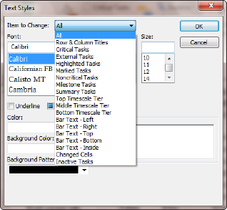

1. Text Styles Dialog with Items to Change Menu. [12-16 Text styles category.tif]
2. Select the settings that you want for the text, including font, font style, font size, color and script.
3. Click OK to apply the formatting.

Text Style formatting will only be applied to the view displayed when it is applied. It will not appear in other views. If the file is saved, the formatting will stay with the view.

## Formatting the Gantt Chart

In addition to text styles you can format the task bars. You can make changes to the shape, color, and pattern, as well as style of the bar.

### Changing the Gantt Bars Quickly Using a Style

With a single click, you can apply a pre-defined style to all bars in a Gantt Chart view.

To apply pre-defined styles to Gantt bars:

1. Apply a Gantt Chart view.
2. In the Format tab, Gantt Chart Style group, click a style in the Gantt Chart Style group.

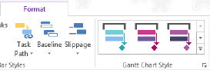

1. Gantt Chart Styles Group. [12-17 Gantt Chart Style group.tif]
2. The style is instantly applied to all the bars in the view.

### Changing the Color, Shape, or Pattern of Gantt Bars

To call attention to task bars in Gantt Chart view, you can change the color, shape, or pattern of individual task bars to separate them from other types of bars. This technique can be used to draw attention to task bars like milestones or summary tasks. Making changes using the Bar Styles box will change only the current view. All bars in the view such as Gantt bars, summaries or milestones will be affected by this change.

To format categories of task bars:

1. Apply a Gantt Chart view.
2. In the Format tab Bar Styles group, click the Format drop-down arrow, and click Bar Styles.

You can also double click within the chart portion of Gantt Chart view, but not on individual bars, to open the Bar Styles dialog box.

1. In the Name field, click the type of bar (such as Task or Progress) that you want to format.
2. Click the Bars tab at the bottom of the box.

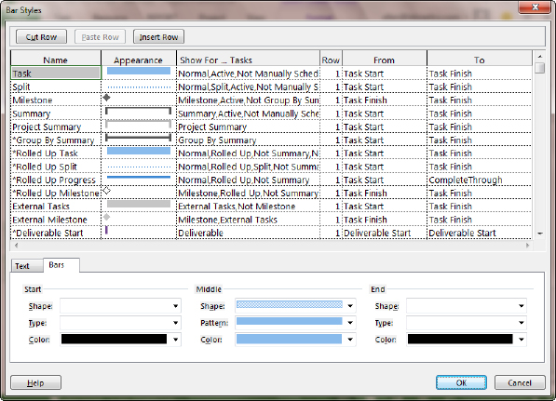

1. Bar Styles Dialog. [12-18 Bar styles dialog box.tif]
2. Under Start, Middle, and End, click the shapes, types or patterns, and colors for the bar.

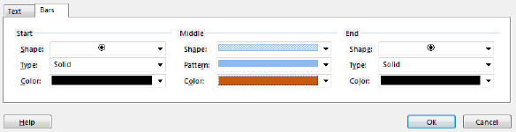

1. Bottom Pane of Bar Styles Dialog – Bars Tab Selected. [12-19 Bottom pane of bar styles.tif]
2. Click OK to save changes.

To highlight a single Gantt bar by changing its formatting, right click on the individual bar and select Format Bar.

### Changing the Appearance of Link Lines Between Gantt Bars

When you link tasks, Project displays link lines on a Gantt Chart view that show the dependency of the linked tasks.

1. Link Line [11-24.png]

You can change the way link lines appear or hide the link lines.

To change the appearance of links between Gantt bars:

1. Apply a Gantt Chart view.
2. In the Format tab, Format group, click Layout.

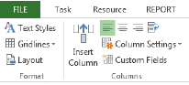

1. Format Tab, Format Section, Layout button. [12-25 Format ribbon Format section.tif]
2. Under Links, click the type of link line that you want to use. If you choose the first type of link, then the link lines will not appear.

Layout box options:

* Links - used to change the look of the link lines or turn them off.
* Date format - used to change the date format on the Gantt chart and will not affect the date shown in the tables.
* Bar Height - used to adjust the Gantt bars.
* Always roll up Gantt bars – used to roll up the Gantt bars when the outline level is collapsed, roll up the Gantt bars (example of rolled up bars is shown below).
* Round bars to whole days – used to make very short tasks more visible.
* Show bar splits - used when you have split tasks. Split tasks will also appear during tracking.
* Show drawings – drawing tools are located on the Format tab. Text boxes and arrows may be drawn on Gantt charts. Use this option to hide the drawings when needed.

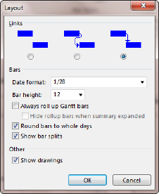

1. Layout Dialog Box. [12-26 Layout box.tif]

# Reporting

Communication is an essential part of project management. Project 2013 provides an abun-dance of textural and graphic reporting options to fulfill the communication requirements needed to help you manage your projects and communicate status to stakeholders.

In this lesson we will discuss:

* Visual reports
* Dashboard reports
* Timeline report

## Visual Reports

Visual reports are graphical type reports that are available in Project 2013. These reports are defined using a template in Project 2013 and use either a Visio PivotDiagram or Excel PivotTable technology to generate the final report. Once a report is generated, changes and fine-tuning of the report can be performed through Visio or Excel.

Since Visual Reports use Pivot table technology, knowledge of Pivot tables is helpful for the project manager to gain the greatest benefit from these reports.

In this lesson we will discuss:

* Overview of Visual Reports
* The Anatomy of Pivot Tables
* Viewing a Visual Report
* Creating a Visual Report template

### Overview of Visual Reports

Visual Reports are reports based on dimensions and measures that produce graphs using Pivot Tables. Pivot Tables will be discussed in the next lesson. When a Visual Report is run, an On-line Analytical Processing (OLAP) cube of data is built based on the metrics stated in the specifications for the Visual Report. After the cube is built, Project 2013 connects to either Visio or Excel to display the report. If an Excel-based report is selected, the report will be based on Pivot Tables. If a Visio-based report is selected, a Visio Pivot Diagram will be produced.

Once a report is generated, it can be manipulated as a Pivot Table and tailored to fit your needs. Types of manipulations include expanding and contracting outline levels, changing field values, selecting options, adding totals and changing the appearance of graphs. After the Visual Reports are generated, they can be saved or published to a reporting website.

Project 2013 provides multiple Visual Report definition templates found in the Visual Reports - Create Report dialog box. Options are available to filter the Excel templates from the Visio tem-plates. All templates are contained in the All tab within the dialog box.

Sub tabs are provided for various report categories, and contain the following report options:

1. Task Summary Tab

|  |  |  |
| --- | --- | --- |
| Report | Content | Excel or Visio |
| Critical Tasks status report (Metric) | Work and Work remaining for critical and non-critical tasks. | Visio |
| Critical Tasks status report (US) | Work and Work remaining for critical and non-critical tasks. | Visio |

1. Resource Summary Tab

|  |  |  |
| --- | --- | --- |
| Report | Content | Excel or Visio |
| Resource remaining work report | Work, Remaining Work, total Work for work resources. | Excel |

1. Assignment Summary Tab

|  |  |  |
| --- | --- | --- |
| Report | Content | Excel or Visio |
| Resource status report (Metric) | Work and Cost values per resource. | Visio |
| Resource status report (US) | Work and Cost values per resource. | Visio |
| Task status report (Metric) | Work and percent of work completed by WBS level. | Visio |
| Task status report (US) | Work and percent of work completed by WBS level. | Visio |

1. Task Usage Tab

|  |  |  |
| --- | --- | --- |
| Report | Content | Excel or Visio |
| Cash flow report | Timephased task cost data. | Excel |

1. Resource Usage Tab

|  |  |  |
| --- | --- | --- |
| Report | Content | Excel or Visio |
| Cash flow report (Metric) | Baseline Cost vs Actual Cost over time by resource type. | Visio |
| Cash flow report (US) | Baseline Cost vs Actual Cost over time by resource type. | Visio |
| Resource Availability report (Metric) | Total capacity, Work and remaining availability per. resource | Visio |
| Resource Availability report (US) | Total capacity, Work and remaining availability per resource. | Visio |
| Resource cost summary report | Resource costs per resource type. | Excel |
| Resource work availability report | Work and remaining availability over time. | Excel |
| Resource work summary report | Work, Actual Work and Remaining Availability per resource. | Excel |

1. Assignment Usage Tab

|  |  |  |
| --- | --- | --- |
| Report | Content | Excel or Visio |
| Baseline Cost Report | Compares Baseline Cost, Actual Cost and Cost. | Excel |
| Baseline Report (Metric) | Baseline, Actual Work and Cost over time. | Visio |
| Baseline Report (US) | Baseline, Actual Work and Cost over time. | Visio |
| Baseline Work Report | Baseline Work, Baseline Cost, and Actual Work. | Excel |
| Budget Cost Report | Budget Cost, Baseline Cost, Cost and Actual Cost. | Excel |
| Budget Work Report | Budget Work, Baseline Work, Work, Actual Work. | Excel |
| Earned Value Over Time Report | Timephased – Actual Cost of Work performed, baseline values and Earned Value. | Excel |

### Anatomy of a Pivot Table

To understand Visual Reports, some understanding of Pivot Tables is helpful. Pivot Tables are flexible tables based on measures and dimensions. The information below is an overview of a Pivot Table based report. Additional information regarding Pivot Tables can be found in any Excel reference book, through software Help, or online.

In the table below, sales data from The Chocolate Company shows that sales of different prod-ucts have occurred in multiple locations. The Chocolate Company also keeps track of the cus-tomer type and products sold. We might want to know total sales by customer type, product or location. Pivot Tables have the flexibility to process any of these report requests quickly.

The data below is the source data that will be used to generate the Pivot Table:

1. Sample data for Pivot table

|  |  |  |  |  |  |
| --- | --- | --- | --- | --- | --- |
| Customer | Customer type | Location | Product | Quantity in bars | Price |
| Customer A | Retail | Chicago | Dark | 48 | 120 |
| Customer B | School | Rome | Milk | 24 | 60 |
| Customer C | Vending | Sydney | White | 12 | 30 |
| Customer D | Retail | Chicago | Dark almonds | 36 | 45 |
| Customer E | School | Rome | Milk almonds | 48 | 120 |
| Customer F | Vending | Sydney | White peanuts | 24 | 60 |
| Customer G | Retail | Chicago | Dark | 12 | 30 |
| Customer H | School | Rome | Milk | 36 | 45 |
| Customer I | Vending | Sydney | White | 48 | 120 |
| Customer J | Retail | Chicago | Dark almonds | 24 | 60 |
| Customer K | School | Rome | Milk almonds | 12 | 30 |
| Customer L | Vending | Sydney | White peanuts | 36 | 45 |
| Customer M | Retail | Chicago | Dark | 48 | 120 |

In the view below, a Pivot Table has been created using the above data. The data below is con-solidated to show sales by Customer type:

1. Pivot table generated in Excel showing Customer type and Sum of Price

|  |  |
| --- | --- |
| Customer Type | Sum of Price |
| Retail | 480 |
| School | 180 |
| Vending | 90 |
| Wholesale | 135 |
| Grand Total | 885 |

In the next example, the table was changed to show sales by Location:

1. Pivot table generated in Excel showing Location and Sum of Price

|  |  |
| --- | --- |
| Location | Sum of Price |
| Chicago | 375 |
| Rome | 255 |
| Sydney | 255 |
| Grand Total | 885 |

In the next example, sales by Product:

1. Pivot table generated in Excel showing Product and Sum of Price

|  |  |
| --- | --- |
| Product | Sum of Price |
| Dark | 270 |
| Dark almonds | 105 |
| Milk | 105 |
| Milk almonds | 150 |
| White | 150 |
| White peanuts | 105 |
| Grand Total | 885 |

Pivot Tables are easily changed to create the type of report necessary for your reporting needs, based on the values contained in the Pivot Table data. Visual Reports will be used to create the Pivot Diagram or Pivot Table but the project manager will need to customize the generated re-port.

### Viewing Visual Reports

Project 2013 comes with built in Visual Report templates to report on cost, work and resource data. Having a specific goal in mind for the type of report you want will help generate more meaningful report data.

To open the Visual Reports – Create Report dialog box:

* Report → Visual Reports

To create a report:

* Select any report.
* Change timeframe (Days, Weeks, Months) for assignment (usage) data.
* Click View.

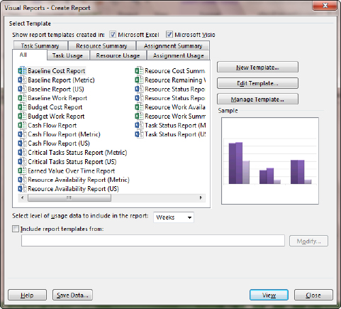

1. Visual Reports selection dialog box. [12-27 Visual reports create.tif]

The report will generate by creating an OLAP cube and will open either Visio or Excel. In the generated Pivot Table select the data to be viewed on the report. Notice that the data viewed on the table can also be viewed in chart format.

Options are available for saving the generated OLAP cube or creating an Access database from the data by clicking the Save Data… button.

Visual report templates contain MS Project Standard field data. If customized field data was created, customized templates can be created to contain the customized fields.

## Dashboard Reports

### What are Dashboard Reports?

Dashboard reports are reports that display project data is tabular and graphic form. Each report displays different data and can be customized to tailor the reports for each user’s needs.

### Introduction to Dashboards

Below is a view of the Overallocated Resources Dashboard Report. Note that it contains two charts each representing different resource data. The first chart represents Actual Work v Remaining Work. The second chart displays resources that are Overallocated at the day level. Each of these reports may be altered to adjust the chart type, chart elements and details of the display data.

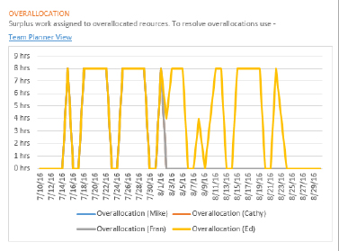

1. Dashboard Report – Actual Work Versus Remaning Work Chart. [Dashboard Report-Actual Work Versus Remaning Work Chart.tif]
2. Dashboard Report – Overallocated Resources Chart [Dashboard Report-Overallocated Resources Chart.tif

### Data included in the Dashboard Reports

Dashboard Reports contain data relating to project progress, variance calculations, and critical path. Below is some of the data which are included in the reports. If you are not using the data needed to populate the reports, the reports will not display properly.

Some of the data needed for the reports includes the following project data values:

* Task Duration, Cost and Work.
* Resource Cost and Work.
* Baseline comparison.
* Status date.
* Status field: Late, On Time, Future

To Display a Dashboard Report:

1. Click on the Reports tab.
2. Click on a Report Category: Dashboards, Resources, Costs, In Progress.

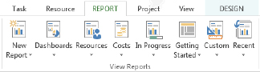

1. Ribbon bar for dashboard reports. [Report ribbon dashboard reports.tif]
2. Click on a Report to display.

To change parameter values displayed on a Dashboard Report:

1. Click on the Reports tab
2. Click on a Report Category: Dashboards, Resources, Costs, In Progress
3. Click on a Report to display
4. Click inside of a graph. Options will appear on the right side of the view.
5. Change options as necessary. Close options by clicking on the X in the upper right corner of the options box.
6. Other changes may be made by clicking on formatting changes on the Design tab which will appear when a Report is selected.

Changes to Dashboard Reports will be remembered within the file and will appear the next time the report is viewed.

Clicking on the Page Breaks button will display the page breaks as they will occur when printing the report. The separate report graphics and tables may be dragged to different pages for printing purposes.

## Timeline View Report

A timeline is a graphic that is usually displayed with long bars and key dates or date ranges. To create a high-level timeline report for an executive (or others who need to see a subset of your schedule), use Timeline view.

### Customizing Timeline Views

The purpose of the Timeline view is to display project tasks using a timeline format and export the view to other applications such as Word, Excel, Outlook and Powerpoint.

Gantt Chart with Timeline is the default view in Project 2013. This view is a split screen with the Timeline view on the top and the Gantt Chart View on the bottom.

To turn Timeline view off/on:

* Task → Gantt Chart
* View → Timeline

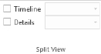

1. Spit view section of the View ribbon. [12-29 Timeline ribbon option.tif]

Below is a view of the default Timeline view. The Timeline view is showing the information for the project summary task. The length of the timeline represents the duration of the project. There is a timeframe window open in the middle to highlight a specific timeframe:

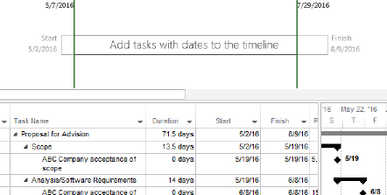

1. Default view of Timeline view. [12-30 timeline view - another option.tif]

To format or add more data to the Timeline view:

* Click inside the Timeline view window
* Click on the Format tab

Below is a view of the Timeline Format tab. Use the buttons on this bar to add additional tasks and format the Timeline view.

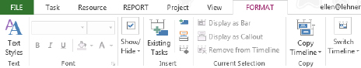

1. Format ribbon for Timeline View. [12-30A Timeline format bar.tif]

Within the Timeline view there is a timeframe window highlighted in the diagram below.

* The Timeframe window may be dragged left and right to emphasize different timeframes of the project schedule. The Gantt bars will adjust as the timeframe window is moved.
* Change the timeframe window by clicking in the timeline view and clicking the zoom slider in the lower right corner of the screen.
* The time density of the Timeline view does not have to match the time density of the Gantt Chart View.
* To turn on and off the Timeframe window, click the Pan & Zoom button on the Format bar.
* Use the Date format button on the Format bar to format the dates in the Timeline view.
* Use the Detailed Timeline button to show task names and dates in the view.

The view below shows the standard Timeline view with the Gantt chart view below:

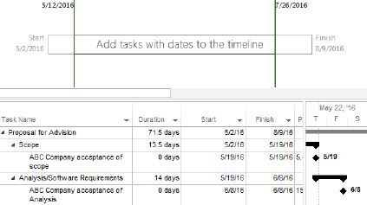

1. Timeline view with Gantt chart. [12-31 Timeline with Gantt.tif]

Adding additional tasks to the Timeline view will help build a better picture of your project. Tasks can be individually included to the Timeline view via the Task Information dialog box under the General tab. Double click a task to display the Task Information dialog box.

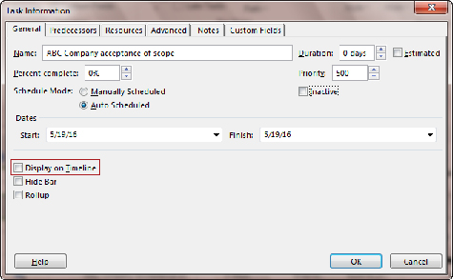

1. Task Information dialog box, General tab showing Display on Timeline option. [12-32 Task info box.ai]

The timeline format tab has several command buttons that will help flag tasks for inclusion into the Timeline view. Clicking the Existing Tasks button will display a list of all tasks for a project where you can scroll through and select the tasks you want displayed in the Timeline view.

To add tasks to the timeline view using the Existing Tasks button:

* Click in the Timeline view.
* Click Existing Tasks.
* Using the check boxes, select the tasks to add.
* Click OK to close.

See below for an example of the Existing Tasks choice list. It is easy to tell the difference be-tween summary and detail tasks:

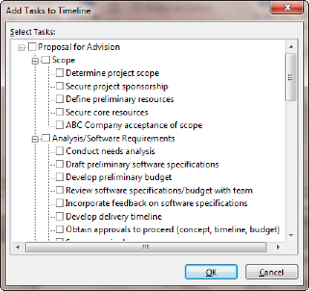

1. Add Tasks to Timeline dialog box. [12-33 Add Tasks to Timeline.tif]

The timeline view should be planned carefully to create a meaningful report. Too much information can confuse the reader. Consider creating a high level tasks report that shows summary sections of work within timeframes. Below is a view where outline Level 1 tasks have been added to the Timeline view.

To add Outline Level 1 tasks (Summaries) to the Timeline view:

* Tasks → Gantt Chart
* View → Outline → Outline level 1
* For each summary task to be added to the Timeline view, Select and Right click. Multiple selections may be made.
* Click Add to timeline

The Timeline view below, displays Outline Level 1 Summary tasks only and the Gantt chart display the same Outline Level 1 Summary tasks.

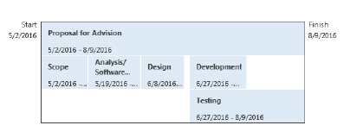

1. Timeline View Showing Outline Level 1 Summary Tasks. [12-34 default Timeline with tasks.tif]

Milestone and formatting for the bars can also be added to the Timeline view.

To add a milestone to the Timeline view:

* Tasks → Gantt Chart
* View → Filter → Milestone
* Select the milestone tasks and right click
* Click Add to timeline.

To add formatting to the bars, click on the bar and click on a formatting tool in the Font section of the Ribbon.

The diagram below displays Outline Level 1 tasks with milestones added and formatting:

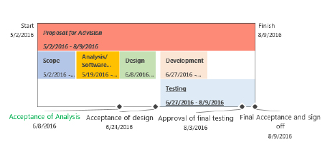

1. Timeline view with Summary tasks, formatting and milestones. [12-35 Milestones added to Timeline.tif]

Tasks may be added to the project using the Timeline view Format tab. When adding tasks using these buttons, the tasks will be added to the end of the project schedule and will start on the first day of the project or the current date depending on the scheduling option. The choices are:

* Adding a new task to the timeline
* Adding a new callout task to the timeline
* Adding a new milestone to the timeline

Below is a view showing a new callout task and a new milestone added to the timeline and the project schedule. Callout tasks are originally placed above the timeline spanning the timeframe of the task. After they are created, they may be dragged to alternate locations within the Timeline View.

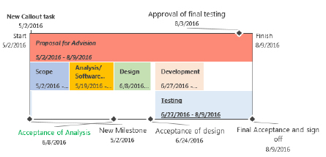

1. Timeline view with Callout task and added milestone. [12-36 Timeline with callout & Milestone.tif]

To display an existing task as a callout task:

* Click on a task in the Timeline view
* Click Display as a Callout

To display a Callout task as a bar:

* Click on the Callout task
* Click Display as Bar

To remove tasks from the Timeline view using the Timeline Format tab:

* Click the task in the Timeline view
* Click Remove from Timeline

Tasks may be formatted and highlighted as necessary. Text styles and format buttons are available on the Timeline Format tab. Changing the colors of the timeline bars is helpful when highlighting information.

Too much information results in a hard to read Timeline view. Select what is important and what will convey your message. The view will become more meaningful and will result in a useful reporting tool. Typically Summary Tasks and Milestones are included in the Timeline view which would provide a high level report.

### Exporting Timeline View

Timeline view is a great visual for executive summaries. To facilitate sharing information with executives, the Timeline may need to be exported to another application.

Timeline view must be displayed before you can export it to another application. The simplest method is to click the Timeline checkbox on the View tab. If this option is unavailable, you may need to uncheck the Details checkbox on the same tab.

To copy a timeline:

1. Click inside the Timeline view.
2. In the Timeline Tools, Format tab, click on Copy Timeline and choose the desired option.

* For e-mail – Timeline size is reduced to fit into an Outlook message. Small size.
* For presentation – Optimized for a PowerPoint presentation. Medium size.
* Full Size – Uses the full size of the timeline as displayed in Project. Large size.

You can paste in Outlook to email it to peers or in PowerPoint to format it further.

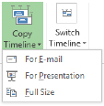

1. Copy timeline options. [Copy timeline.tif]

You can also save the Timeline as an Adobe Acrobat file using the File, Export, Create PDF/XPS Document option.

# Key Points to Remember

* Projects can be saved in PDF format to e-mail to others without access to Project or when you want to ensure the data does not change.
* Print and Page Setup options can be tailored to alter the layout of printouts or PDF files.
* Use Text Styles to format a specific type of task globally.
* Gantt Chart Styles globally change the display of the Gantt bars.
* Use Bar Styles to format a specific type of Gantt bar globally.
* Use Layout to modify the link line appearance.
* Visual reports extract data into either Visio PivotDiagrams or Excel PivotTables where they can be modified further.
* Dashboard reports include graphical and tabular components and are very visual ways of representing scheduling information.
* Use Timeline view to create a graphical executive summary of your schedule.